AP21110010931
CSE - O

RAILWAY MANAGEMENT SYSTEM

Aim:
The aim of the Railway Management System is to efficiently manage and organize railway operations, including information about trains, passengers, reservations, ticketing, and other relevant data.

Description:
The Railway Management System typically includes the following components:

Train Information: Stores information about the trains, such as train name, departure and arrival stations, schedule, and seat availability.

Passenger Information: Contains details about passengers, including name, contact information, and ID.

Reservation Management: Manages passenger reservations, including reservation ID, passenger ID, train ID, and seat information.

Ticketing and Payment: Tracks ticket information, including the reservation, fare, and payment details.

Station Information: Stores information about railway stations, their names, and location details.

Employee Information: Manages information about railway staff, such as station managers and ticketing agents.

Tables Required with Description:

Train Table:
Train_ID (Primary Key)
Train_Name
Departure_Station
Arrival_Station
Departure_Time
Arrival_Time
Total_Seats
Available_Seats

Passenger Table:
Passenger_ID (Primary Key)
Name
Contact_Number
Address

Reservation Table:
Reservation_ID (Primary Key)
Passenger_ID (Foreign Key)
Train_ID (Foreign Key)
Seat_Number
Date

Ticket Table:
Ticket_ID (Primary Key)
Reservation_ID (Foreign Key)
Fare
Payment_Status

Station Table:
Station_ID (Primary Key)
Station_Name
Location

Employee Table:
Employee_ID (Primary Key)
Name
Position
Contact_Number

E.R Diagram:

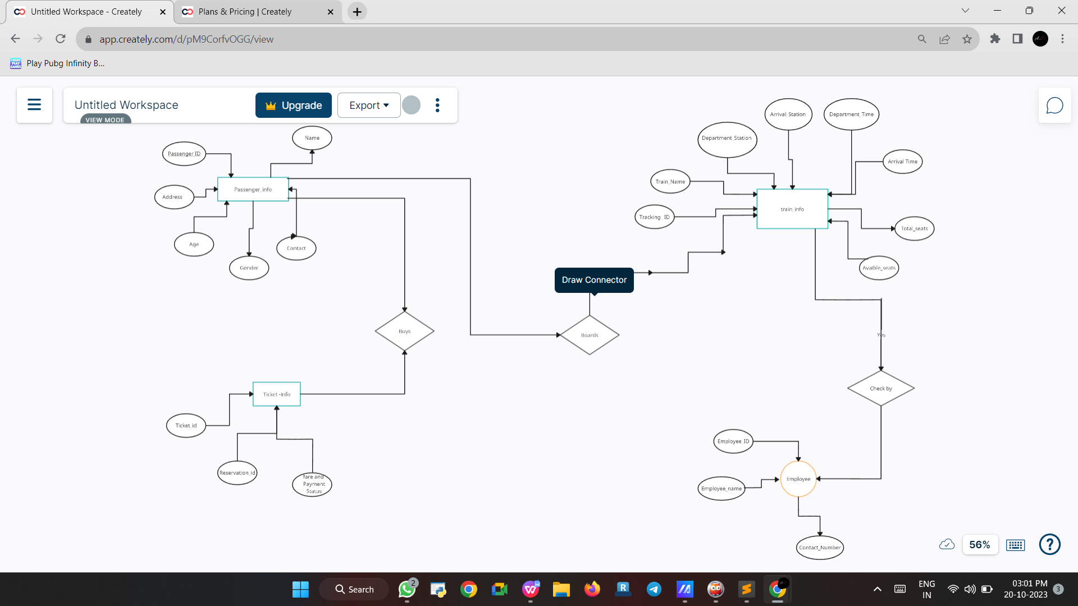
Relational_Schema:

Train Table:

Train_ID (Primary Key): A unique identifier for each train.
Train_Name: The name of the train.
Departure_Station: The station where the train starts its journey.
Arrival_Station: The station where the train ends its journey.
Departure_Time: The time when the train departs from the departure station.
Arrival_Time: The time when the train arrives at the arrival station.
Total_Seats: The total number of seats on the train.
Available_Seats: The number of seats that are currently available on the train.

Passenger Table:
Passenger_ID (Primary Key): A unique identifier for each passenger.
Name: The name of the passenger.
Contact_Number: The contact number of the passenger.
Address: The address of the passenger.

Reservation Table:
Reservation_ID (Primary Key): A unique identifier for each reservation.
Passenger_ID (Foreign Key): Links to the Passenger table to associate reservations with passengers.
Train_ID (Foreign Key): Links to the Train table to specify which train the reservation is for.
Seat_Number: The seat number reserved by the passenger.
Date: The date of the reservation.

Ticket Table:
Ticket_ID (Primary Key): A unique identifier for each ticket.
Reservation_ID (Foreign Key): Links to the Reservation table to associate tickets with reservations.
Fare: The cost or fare for the reservation.
Payment_Status: Indicates whether the payment for the ticket has been made or not.

Station Table:

Station_ID (Primary Key): A unique
identifier for each station.
Station_Name: The name of the station.
Location: The location or address of the station.

Employee Table:
Employee_ID (Primary Key): A unique identifier for each employee.
Name: The name of the employee.
Position: The job position or role of the employee.
Contact_Number: The contact number of the employee.

